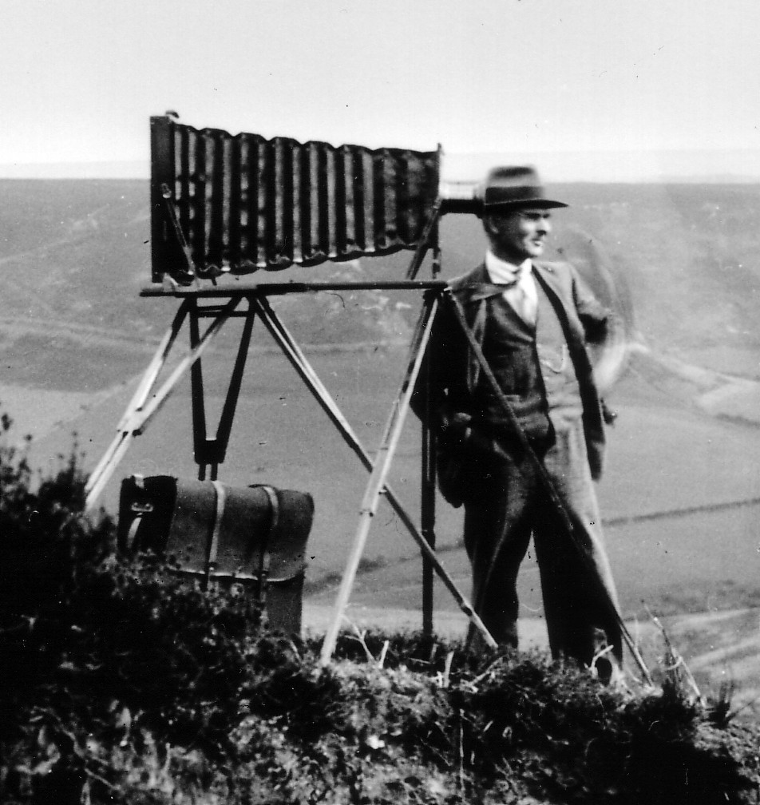
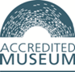
Beck Isle Museum
SCHOOLS BOOKING FORM

It is essential that you contact us to confirm your required date is available

Name of School: ………………………………………………………………………………………………
Address: …………………..…………………………………………………………………………………..
…………………………………………………………………………………………………………………

Name of contact: ……………………..………………………..Visit Date ……………………………………

Telephone …………...……..……..…………. Email: ……………………………………………………….

Number of Children ………………… Ages …….……………Number of Adults ………………………….

Arrival time ………….………………………………..Departure time ………………………………….…..

Special needs or requirements …………………………………………………………………………………

Organisers signature…………………………………..………………… Date ……………………………
Please allow approximately 2 hours for your visit. Please inform us if you are running late on your visit day
Cost: Children £3 per head. Teachers/adults £3 per head (cheque/cash on day of visit only)

